*ORACLE DB SQL QUERIES - 24.07.2023 - ERKAM DOĞRUL - i2i Systems*

1. SELECT EMPLOYEE_ID, FIRST_NAME, DEPARTMENT_NAME FROM HR.EMPLOYEES INNER JOIN HR.DEPARTMENTS ON HR.DEPARTMENTS.DEPARTMENT_ID = HR.EMPLOYEES.DEPARTMENT_ID;

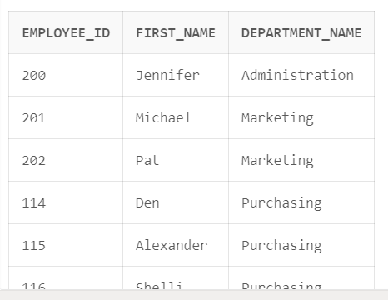

1. SELECT e.EMPLOYEE_ID AS employee_id , m.EMPLOYEE_ID AS manager_id FROM HR.EMPLOYEES e JOIN HR.EMPLOYEES m ON e.MANAGER_ID = m.EMPLOYEE_ID;

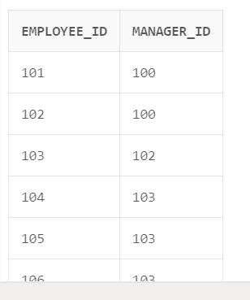

1. **a)** SELECT SUBSTR(PHONE_NUMBER, 1, 3) AS OPERATOR, COUNT(EMPLOYEE_ID) AS TOTAL

FROM HR.EMPLOYEES GROUP BY SUBSTR(PHONE_NUMBER, 1, 3);

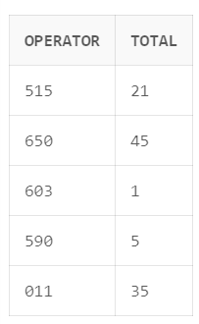

**b)** SELECT *

FROM (

SELECT SUBSTR(PHONE_NUMBER, 1, 3) AS OPERATOR, COUNT(EMPLOYEE_ID) AS TOTAL

FROM HR.EMPLOYEES GROUP BY SUBSTR(PHONE_NUMBER, 1, 3) )

PIVOT (

MAX(TOTAL)

FOR OPERATOR IN ('515' AS "515", '650' AS "650", '603' AS "603", '590' AS "590", '011' AS "011")

);

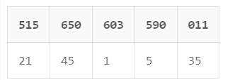

1. **a)** CREATE TABLE NEW_EMPLOYEE AS SELECT * FROM HR.EMPLOYEES ;

**b)** SELECT * FROM NEW_EMPLOYEE;

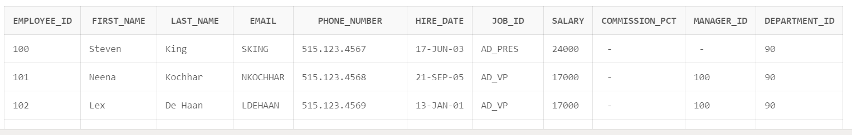

**c)** INSERT INTO NEW_EMPLOYEE VALUES(99,'Mehmet', 'Yılmaz', 'HOTMAIL', '530.123.4567','24-JUL-23' , 'FI_ACCOUNT', 30000, 0.2, 125, 30);

**d)** SELECT * FROM NEW_EMPLOYEE WHERE EMPLOYEE_ID = 99 AND FIRST_NAME = 'Mehmet';



**e)** UPDATE NEW_EMPLOYEE SET PHONE_NUMBER = '530.123.4568', SALARY = 40000

WHERE EMPLOYEE_ID = 99;



**d)** DELETE FROM NEW_EMPLOYEE WHERE EMPLOYEE_ID = 99 ;

**e)** DROP TABLE NEW_EMPLOYEE;

1. SELECT

CONCAT(

(SUBSTR(FIRST_NAME, 1, LENGTH(FIRST_NAME) - 3) ),

RPAD('*', 3, '*') , ' ', (SUBSTR(LAST_NAME, 1, LENGTH(LAST_NAME) - 3) ),

RPAD('*', 3, '*')

) AS CUSTOMER_FULL_NAME

FROM HR.EMPLOYEES;

